**Openreach - Temporary Road Closure - Longend Lane, Collier Street - 10th April 2025 (Maidstone District)**

Due to works planned to be undertaken by **Openreach**, it will be necessary to close part of Longend Lane, Collier Street, from 10th April 2025 with estimated completion by 10th April 2025.

Longend Lane, Collier Street, will be closed outside Longends Bungalow, between the hours of 09:30 and 15:30 only. To the extent indicated by signs and barriers on site.

The alternative route for any through traffic is via Green Lane, B2162 Collier Street, Longend Lane and vice versa.

Pedestrian access will be maintained during the works.

The closure is required for the safety of the public and workforce to allow pole testing works to be carried out, works are undertaken by Openreach.

For the most up to date information on these works please visit: <https://one.network/?tm=141622793>

For information regarding this closure please contact Openreach on 08000 282 229, who will be able to assist with the scope of these works.

The Kent County Council Highways Helpline phone number is: 03000 418181

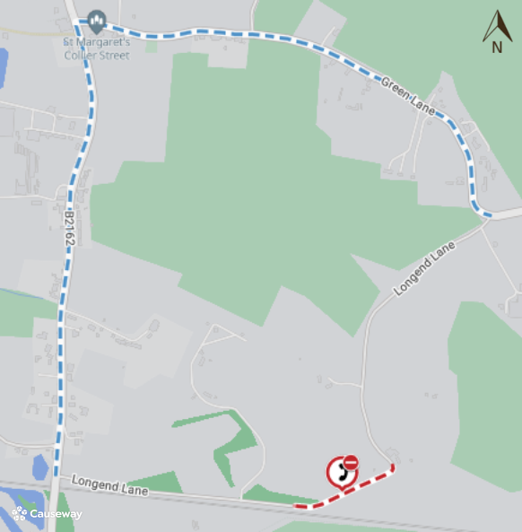

Imagery © 2025 [MapTiler](https://www.maptiler.com/copyright/) | Imagery © 2025 [Hexagon](https://hexagon.com/legal) | © [MapTiler](https://www.maptiler.com/copyright/) © [OpenStreetMap contributors](https://www.openstreetmap.org/copyright)

This bulletin contains public information and can be forwarded to any other road users who may be affected. Every care is taken to ensure the accuracy of the information, but no liability can be accepted for any changes or errors.  
Road names are taken from the National Street Gazetteer, which can be viewed on [one.network](https://one.network), with alternative names given where known.

For details of roadworks, please see [One.Network](https://One.Network)